1. Design DFA using simulator to accept the string having ‘ab’ as substring over the set {a,b}

OUTPUT:-

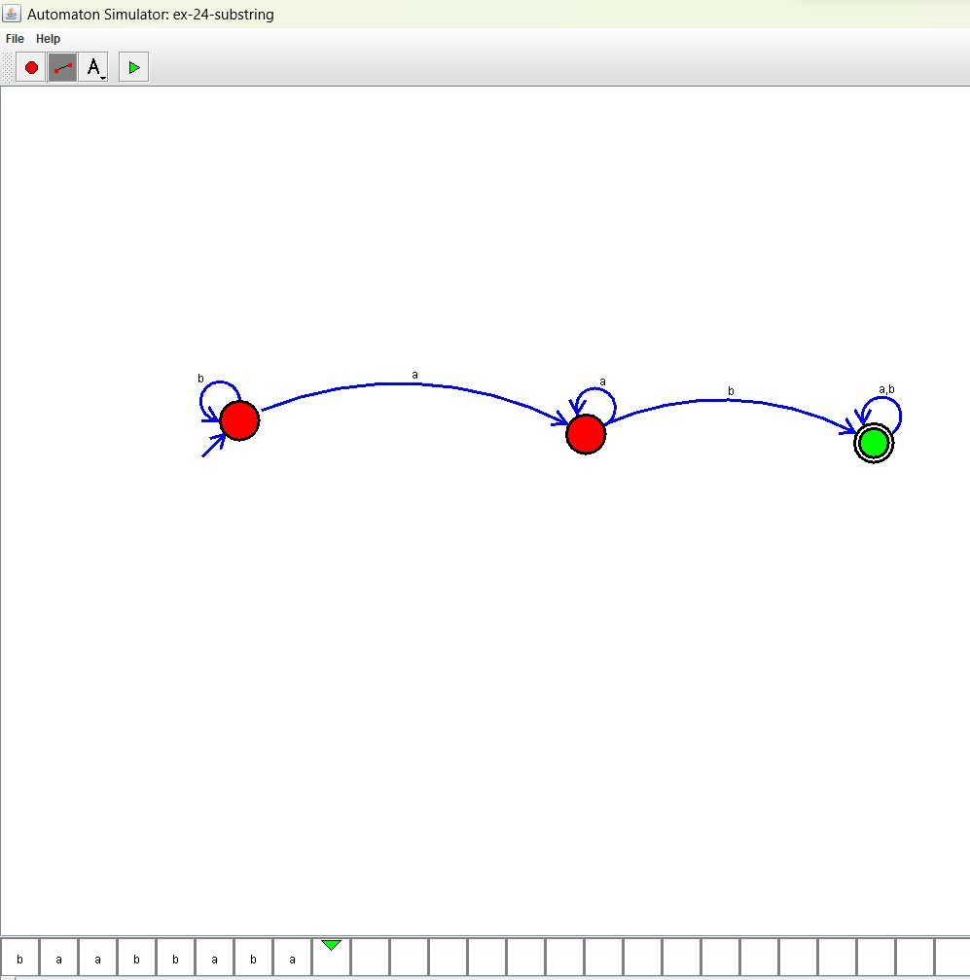

**RESULT**: THE DFA RUN SUCCESFULLY USING SIMULATOR BASED ON GIVEN STRINGS